**Project Name: - Blue Waters**

**Name: -Parveez Ali**

**Database systems-CPSC-50900-005**

**ID: L30062935**

**Assignment: Week 5 Project Part 4a**

**GitHub link: -**

**Current Date: -12/01/2022**

**Part- 4(a)**

**1. Create the SQL script for creating your data tables. You should have 1 table per entity for a total of 5 tables. You can either write this in one script or split your work into 5 small scripts. Save and submit script(s) to your GitHub.**

I wrote the SQL script for creating data tables and uploaded my “.sql” files to GitHub.

**2. Create the SQL script to load your data files into your tables. Again, you may split up your script. Save and submit your work to your GitHub.**

I wrote the SQL script to load data files into tables and uploaded my “.sql” files to GitHub.

**3. Take screen captures of your data tables that show they are empty. I only need one screen, so if you can only fit two or three tables to a screen, that’s fine. Then take a screen capture of the load command after it successfully executes. Then finally take a screen capture of the same tables populated with data.**

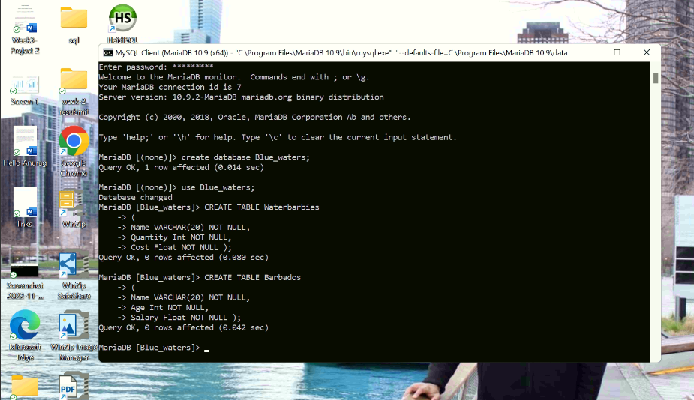

**Screen capture for empty tables.**

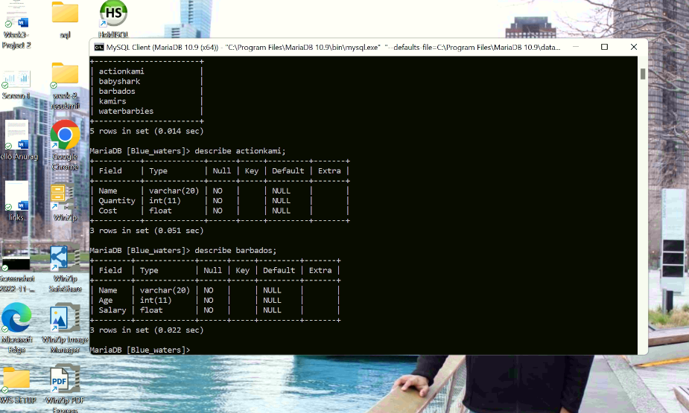

**Screen capture of load command.**

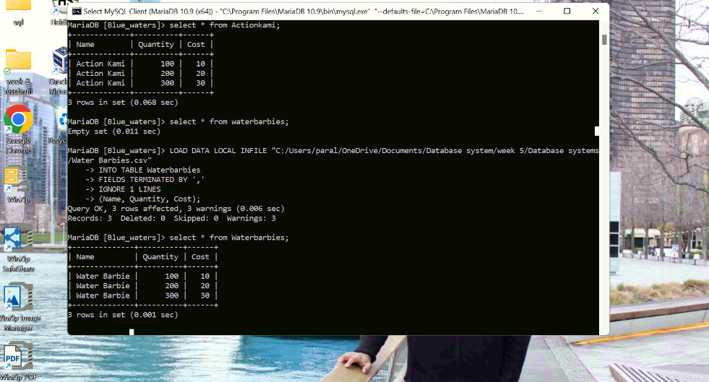

**Screen capture of populated tables.**

